BUSINESS INSIGHTS

Retail Sales & Customer Performance Analysis
Dataset: Retail Sales Dataset | Records: 9,994 | Tools: Python, Pandas, SQL, Power BI

1.Objective:
The objective of Day 33 is to convert analysis results into actionable business insights. An observation states what the data shows; an insight explains why it matters and what the business could do next.

Finding | Evidence | Business Impact
1.The business generated approximately ₹22.97 lakh in sales with a profit margin of 12.47%. | Total Sales: ₹22.97 lakh; Total Profit: ₹2.86 lakh; Profit Margin: 12.47%. | The business should monitor revenue and profitability together to understand whether sales growth is generating sufficient profit.
2.Technology is the most profitable category, while Furniture has a significantly lower profit margin. | Technology profit: ₹1,45,454.95; Furniture profit: ₹18,451.27. Their profit margins are 17.40% and 2.49%, respectively. | Investigate Furniture pricing, discounts, and costs to identify opportunities to improve profitability.
3.Sean Miller is the highest-revenue customer in the current dashboard view. | Total sales attributed to Sean Miller: ₹25,043.05. | Analyze this customer's purchasing patterns and maintain the relationship through appropriate customer retention strategies.
4.Newell 308 has very low recorded sales compared with the other products in the Bottom 10 ranking. | Total Sales: 8.40 | Review product demand, sales history, pricing, and stock availability to determine whether any action is needed.
5.Canon image CLASS 2200 Advanced Copier is the highest-revenue product in the current dashboard view. | Total Sales: ₹61,599.82 | Analyze its sales and profit contribution to understand what makes this product successful and whether its performance can be sustained.
6.Emily Phan has the highest customer order count in the displayed analysis. | Customer Order Count: 17 | Analyze this customer's purchasing frequency and consider suitable strategies to encourage continued engagement.
7.High-value customers contribute more than half of total sales, making them an important customer segment. | Revenue: ₹12,62,665.43; contribution: 54.97%. | Focus on customer satisfaction, retention, and relevant product recommendations to maintain this segment's contribution
8.November recorded the highest monthly sales in the displayed analysis. | Total Sales: 352,461.07 | Review November's sales patterns and seasonal demand to help plan inventory, promotions, and staffing for peak sales periods.
9.Technology generates the highest total profit among the three product categories, while Furniture generates the lowest. | Technology: 145,454.95; Office Supplies: 122,490.80; Furniture: 18,451.27. | Analyze the factors driving Technology's profitability and investigate Furniture's pricing, discounts, costs, and product mix to identify improvement opportunities.
10.The West region generates the highest sales, while the South region generates the lowest among the four regions. | West: 725,457.82; East: 678,781.24; Central: 501,239.89; South: 391,721.91. | Analyze successful sales practices in the West region and investigate demand, product mix, and sales opportunities in the South region to identify potential growth strategies.

Key Business:

No. | Business Area | Key Finding
1 | Customer Revenue | Sean Miller is the highest-revenue customer in the displayed ranking, with sales of 25,043.05.
2 | Product Revenue | Newell 308 has the lowest recorded sales among the products shown in the Bottom 10 chart, at 8.40.
3 | Product Revenue | Canon image CLASS 2200 Advanced Copier leads the displayed Top 10 products chart, with sales of 61,599.82.
4 | Customer Orders | Emily Phan has the highest customer order count shown, at 17.
5 | Customer Segmentation | High-value customers contribute 1,262,665.43, representing 54.97% of total sales.
6 | Monthly Sales | November has the highest monthly sales shown, at 352,461.07.
7 | Category Profitability | Technology generates the highest total profit, at 145,454.95.
8 | Category Profitability | Furniture generates the lowest total profit, at 18,451.27.
9 | Regional Sales | West leads regional sales, at 725,457.82.
10 | Regional Sales | South has the lowest regional sales, at 391,721.91.

2. Key Business Recommendations:

1. Improve Customer Retention
Identify high-value customers and develop suitable retention strategies to encourage repeat purchases.
2. Review Low-Revenue Products
Investigate products with very low sales to understand customer demand, pricing, and inventory requirements.
3. Optimize Product Profitability
Analyze category-level profit, discounts, and costs to identify opportunities to improve profitability, particularly in Furniture.
4. Prepare for Seasonal Demand
Use monthly sales trends to support inventory planning, promotional campaigns, and resource allocation during high-sales periods.
5. Improve Regional Sales Performance
Study sales patterns in the West region and investigate opportunities to increase sales in the South region.

3. Key Performance Indicator (KPI) Summary:
KPI | Value | Business Significance
Total Sales | ₹22,97,200.86 | Measures the total revenue generated from sales.
Total Profit | ₹2,86,397.02 | Measures the profit generated by the business.
Total Orders | 5,009 | Indicates the number of orders recorded.
Total Customers | 793 | Indicates the number of distinct customers identified.
Average Order Value (AOV) | ₹458.61 | Shows the average sales value per order, subject to the measure's calculation.
Profit Margin | 12.47% | Shows the proportion of sales retained as profit.
Total Quantity | 38K approximately | Indicates the total quantity of products sold.

Note on KPI Values:
KPI values are rounded for presentation purposes. Total Sales, Total Profit, and Average Order Value are displayed to two decimal places. Total Quantity is shown approximately as 38K. Percentages and other figures may be rounded, so minor differences may occur when compared with detailed reports.

4. Dashboard Overview:
The Power BI dashboard provides an interactive overview of retail sales and customer performance. It includes key performance indicators, customer analysis, product performance, category profitability, regional sales, and monthly sales trends. Interactive slicers allow users to filter the data by year, month, region, and category.

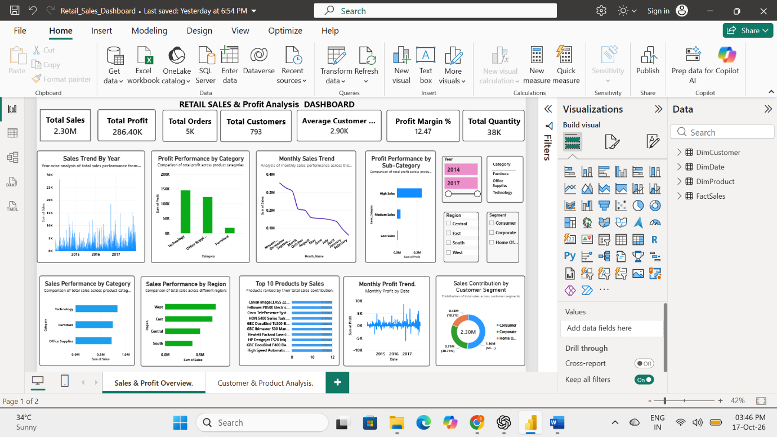

5. Key Findings Summary:
The analysis of retail sales and customer performance identified several important business trends. Technology generated the highest profit among the three product categories, while Furniture generated the lowest profit. The West region recorded the highest sales, and November showed the highest monthly sales among the reported months. Customer analysis also identified high-value customers and highlighted products with comparatively low revenue. These findings can help the business improve profitability, strengthen customer relationships, and make better sales decisions.

